Starting with R
Group members: Ida, Marie, Mark & Ina

For this assignment, submit here a document that lists your solution and a Github repository URL where you deposited your screenshot :
a) create a Github repository in github.com/Digital-Methods-HASS organization following instructions in slides in Brightspace (you need to acquire a login first, send usename to assistant, and accept an invitation before you can join the organization)
b) present the R code you used to produce answers to the questions below (either write up a text file or post your cleaned up R script in Github) and then
c) take a screenshot of your working environment and put it in Github (via upload file button on top right).

Questions:
1) Use R to figure out how many elements in the vector below are greater than 2.
rooms <- c(1, 5, 2, 3, 1, NA, 3, 1, 3, 2, NA, 1, 8, 3, 1, 4, NA, 1, 3, 1, 2, 1, 7, 1, NA, 4, 3 ,1 ,7 ,2 ,1 ,NA ,1, 1, 3)
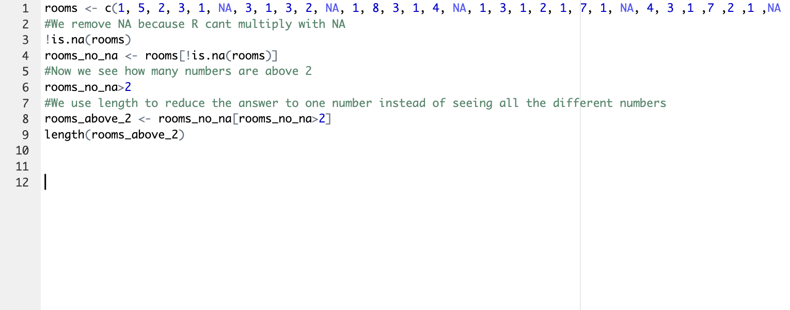
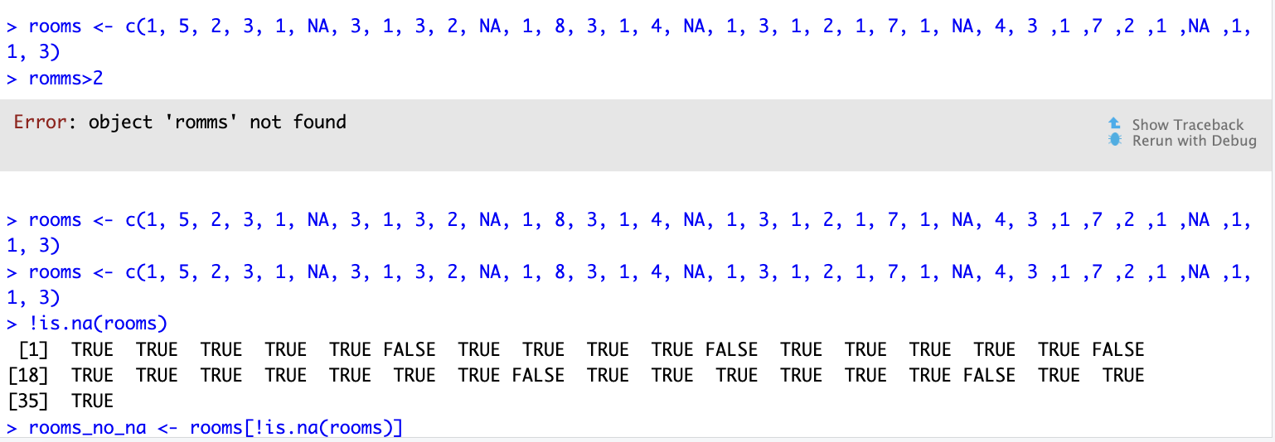

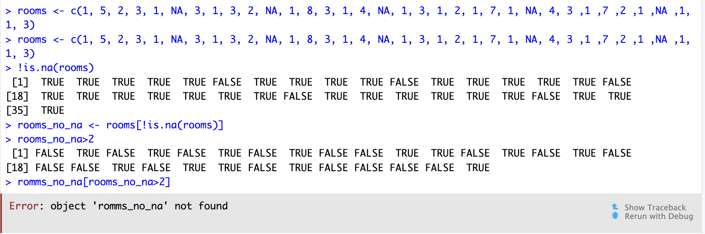
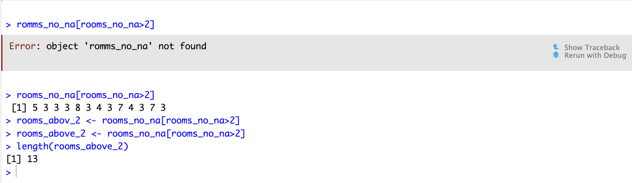

2) Which function tells you the type of data the 'rooms' vector above contains?
The function str() gives an overview of the structure of an object and its element.
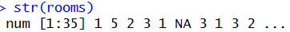

3) What is the result of running the median() function on the above 'rooms' vector?
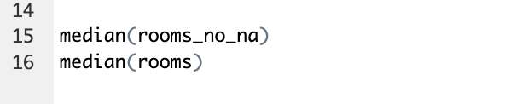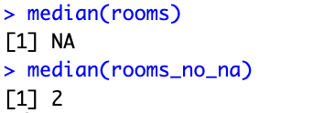
When running the median command with median(rooms) R studio gives us a value of NA, because we have not removed the NA lines from the equation. When we removed the NA lines we got a result of 2

4) In order to submit a screenshot of RStudio, do the following first: Inside your R Project (.Rproj), install the 'tidyverse' package and use the download.file() and read_csv() function to read the SAFI_clean.csv dataset into your R project as 'interviews' digital object (see instructions in https://datacarpentry.org/r-socialsci/setup.html and 'Starting with Data' section). Take a screenshot of your RStudio interface showing
a) the line of code you used to create the object 'interviews', incl. the output in the console,

b) the 'interviews' object in the "Environment" top right pane , and
c) the file structure of your R project in the bottom right "Files" pane.
Save the screenshot as a .png image and put it in your AUID_lastname_firstname repository inside the class Github organisation (www.github.com/Digital-Methods-HASS) or equivalent. Place here the URL leading to the screenshot in your repository.
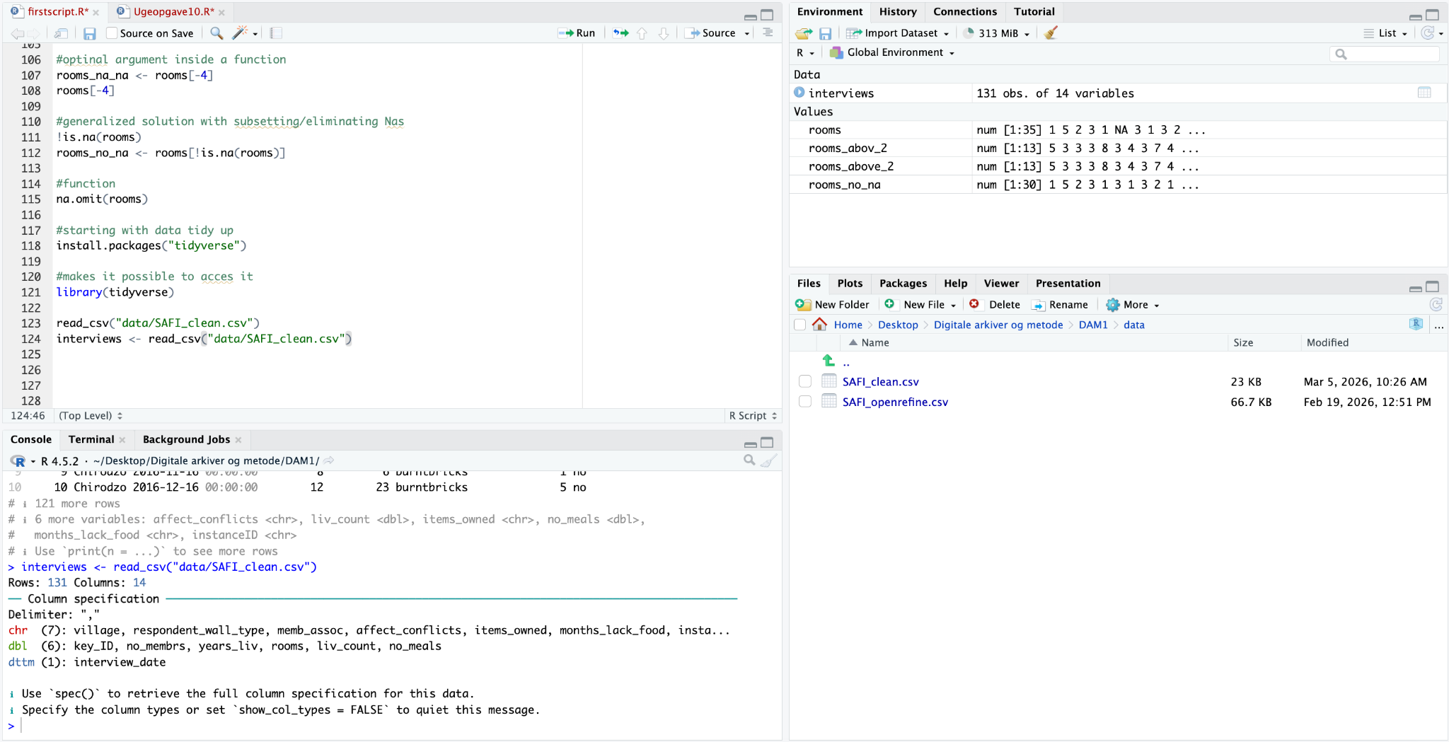
5) Challenge: Tidy up your Danish monarchs dataset (you created last week) sufficiently so that you can load it into R as a tibble using the read_csv() and calculate the mean() and median() duration of their rule over time. Remember you can reload the dataset infinitely and tweak the loading as you discover issues :)
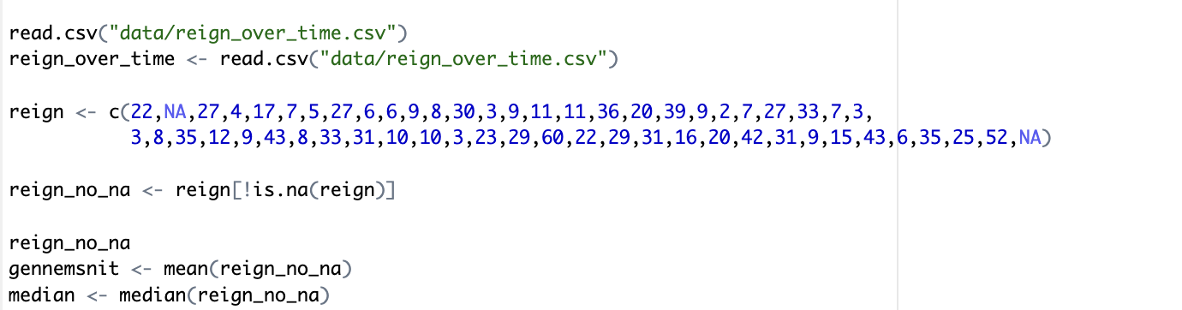
Firstly we make R read our dataset over the danish monarchs reign over time. Then we remove all the NA’s. Then we find then mean of reign_no_na, which is 19,6, and means that the average of a danish monarch's reign time is 19,6 years. Then we find the median, which is 16.
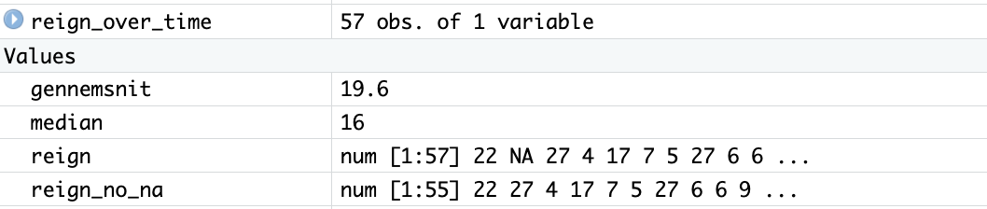
By using R we find the median of

How to submit this homework? Type up the solutions to the tasks (= code that got you the results + the results) , include the URL to the screenshot in a document/pdf and upload to Brightspace.

